Open Shapes
# Source: AI Source: Provided by: [Data Path: Persons Table -> ID Column: 1, Name_En Column: Motasem Essam] -> From: [ChatGPT] on [7/25/2026]
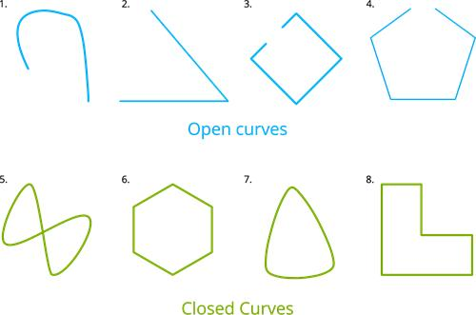
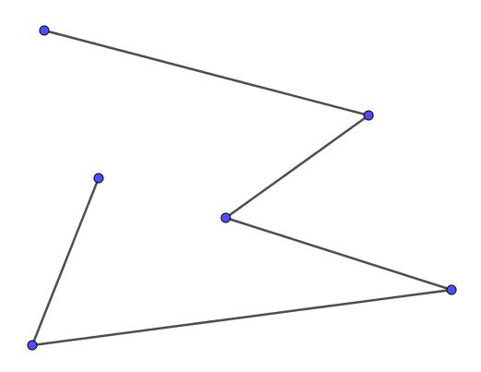
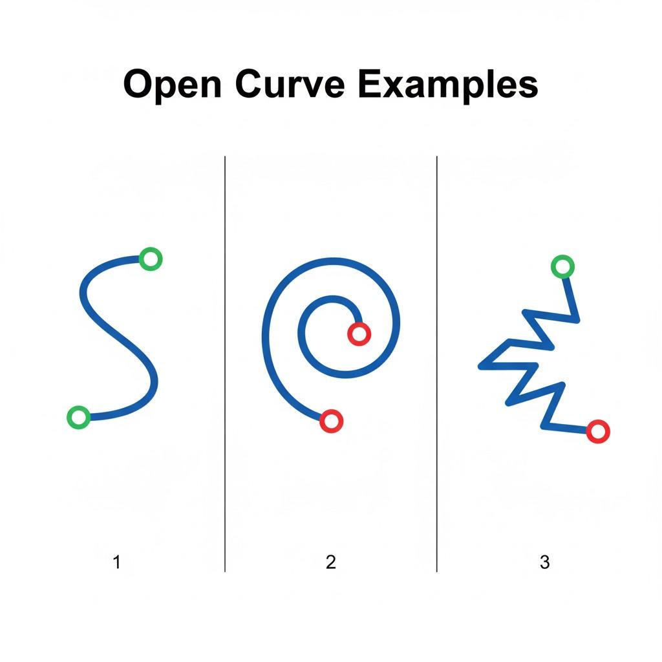
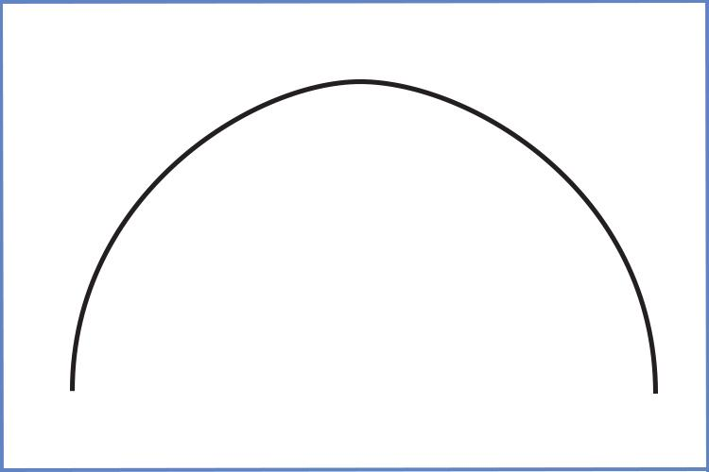
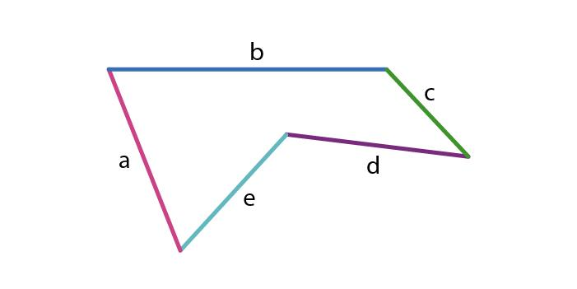

Definition
# Source: AI Source: Provided by: [Data Path: Persons Table -> ID Column: 1, Name_En Column: Motasem Essam] -> From: [ChatGPT] on [7/25/2026]
An Open Shape is a two-dimensional geometric figure whose boundary does not form a complete loop. The endpoints of the boundary do not meet, leaving one or more gaps or openings.
Unlike closed shapes, open shapes do not completely enclose an interior region, so they do not have a defined enclosed area.

Characteristics
# Source: AI Source: Provided by: [Data Path: Persons Table -> ID Column: 1, Name_En Column: Motasem Essam] -> From: [ChatGPT] on [7/25/2026]
An open shape:
- Does not have a complete boundary.
- Has one or more open endpoints.
- Does not enclose an interior region.
- Has measurable length.
- Usually has no enclosed area.
- May be formed from:
  - Straight line segments.
  - Curves.
  - A combination of straight and curved parts.

Illustration

Open Straight Shape (Line Segment)
# Source: AI Source: Provided by: [Data Path: Persons Table -> ID Column: 1, Name_En Column: Motasem Essam] -> From: [ChatGPT] on [7/25/2026]
A────────────B
The endpoints A and B are not connected.

Open Polyline
# Source: AI Source: Provided by: [Data Path: Persons Table -> ID Column: 1, Name_En Column: Motasem Essam] -> From: [ChatGPT] on [7/25/2026]
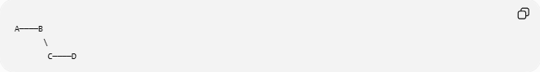
A────B
\
C────D
A connected path of line segments that does not close.

Open Curved Shape (Arc)
# Source: AI Source: Provided by: [Data Path: Persons Table -> ID Column: 1, Name_En Column: Motasem Essam] -> From: [ChatGPT] on [7/25/2026]
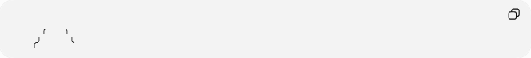
╭────╮
╭╯ ╰
An arc is part of a circle but does not form a complete loop.

Mathematical Representation
# Source: AI Source: Provided by: [Data Path: Persons Table -> ID Column: 1, Name_En Column: Motasem Essam] -> From: [ChatGPT] on [7/25/2026]
An open shape can be represented by a set of points:
$$S=P_{1},P_{2},P_{3},…,P_{n}$$
where:
$$P_{1}≠P_{n}$$
The starting point and ending point are different.

Types of Open Shapes

1. Open Polygonal Shapes
# Source: AI Source: Provided by: [Data Path: Persons Table -> ID Column: 1, Name_En Column: Motasem Essam] -> From: [ChatGPT] on [7/25/2026]
Made from straight line segments but not closed.
Examples:
- Open polyline.
- Broken line.
- Path.
Example:
A────B────C

2. Open Curved Shapes
# Source: AI Source: Provided by: [Data Path: Persons Table -> ID Column: 1, Name_En Column: Motasem Essam] -> From: [ChatGPT] on [7/25/2026]
Made from curves without closing.
Examples:
- Arc.
- Parabola.
- Hyperbola.

3. Open Mixed Shapes
# Source: AI Source: Provided by: [Data Path: Persons Table -> ID Column: 1, Name_En Column: Motasem Essam] -> From: [ChatGPT] on [7/25/2026]
Contain both straight and curved parts.
Examples:
- Open arch.
- Partial rounded rectangle.

Examples
# Source: AI Source: Provided by: [Data Path: Persons Table -> ID Column: 1, Name_En Column: Motasem Essam] -> From: [ChatGPT] on [7/25/2026]
Example 1 – Line
────────────
An infinite open straight shape.

Example 2 – Ray
A────────────→
A shape with one endpoint extending infinitely.

Example 3 – Arc
A portion of a circle:
$$\overset{⌢}{AB}$$

Example 4 – Parabola
$$y=x^{2}$$
An open curve extending infinitely.

Properties
# Source: AI Source: Provided by: [Data Path: Persons Table -> ID Column: 1, Name_En Column: Motasem Essam] -> From: [ChatGPT] on [7/25/2026]
1. No Enclosed Region
An open shape cannot contain an interior area.

2. Has Endpoints
Finite open shapes usually have:
- Starting point.
- Ending point.

3. Length Can Be Measured
Examples:
Line segment:
$$L=\left|AB\right|$$
Curve:
$$L=\text{arc length}$$

4. Does Not Separate Interior and Exterior
Because there is no complete boundary.

Open Shape vs Closed Shape
# Source: AI Source: Provided by: [Data Path: Persons Table -> ID Column: 1, Name_En Column: Motasem Essam] -> From: [ChatGPT] on [7/25/2026]
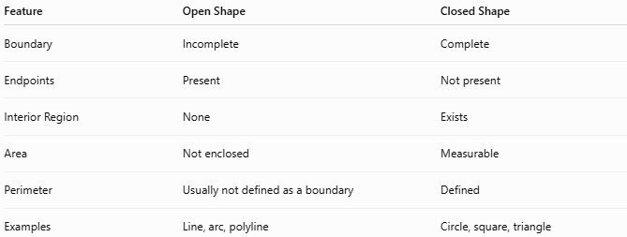
Feature | Open Shape | Closed Shape
Boundary | Incomplete | Complete
Endpoints | Present | Not present
Interior Region | None | Exists
Area | Not enclosed | Measurable
Perimeter | Usually not defined as a boundary | Defined
Examples | Line, arc, polyline | Circle, square, triangle

Open Shapes in Geometry
# Source: AI Source: Provided by: [Data Path: Persons Table -> ID Column: 1, Name_En Column: Motasem Essam] -> From: [ChatGPT] on [7/25/2026]
Open shapes include:
Straight Open Shapes
- Line segment.
- Ray.
- Line.
- Open polyline.
Curved Open Shapes
- Arc.
- Spiral.
- Parabola.
- Hyperbola.
Mixed Open Shapes
- Open curve with straight sections.
- Incomplete composite boundaries.

Real-World Examples
# Source: AI Source: Provided by: [Data Path: Persons Table -> ID Column: 1, Name_En Column: Motasem Essam] -> From: [ChatGPT] on [7/25/2026]
Open shapes appear in:
- Roads.
- Rivers.
- Railway paths.
- Walking trails.
- Electrical wires.
- Open fences.
- Flight paths.
- Drawing strokes.
- Computer graphics paths.

Applications
# Source: AI Source: Provided by: [Data Path: Persons Table -> ID Column: 1, Name_En Column: Motasem Essam] -> From: [ChatGPT] on [7/25/2026]
Open shapes are used in:
- Plane Geometry
- Coordinate Geometry
- GIS (Geographic Information Systems)
- CAD (Computer-Aided Design)
- Computer Graphics
- Engineering
- Robotics
- Navigation Systems
- Cartography

Advantages
# Source: AI Source: Provided by: [Data Path: Persons Table -> ID Column: 1, Name_En Column: Motasem Essam] -> From: [ChatGPT] on [7/25/2026]
Studying open shapes helps to:
- Represent paths and movement.
- Model routes and networks.
- Describe curves and trajectories.
- Create drawings and designs.
- Approximate complex forms.

Limitations
# Source: AI Source: Provided by: [Data Path: Persons Table -> ID Column: 1, Name_En Column: Motasem Essam] -> From: [ChatGPT] on [7/25/2026]
Open shapes:
- Cannot define enclosed areas.
- Do not have an interior region.
- Cannot directly represent solid boundaries.
- Often require additional boundaries to create closed figures.

Comparison with Other Shape Classifications
# Source: AI Source: Provided by: [Data Path: Persons Table -> ID Column: 1, Name_En Column: Motasem Essam] -> From: [ChatGPT] on [7/25/2026]
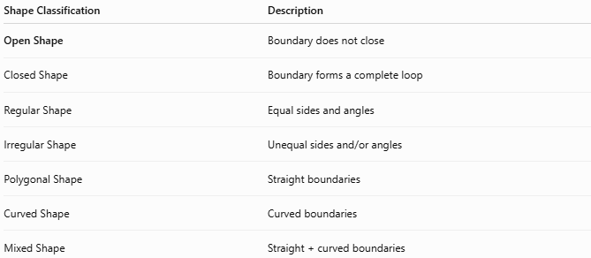
Shape Classification | Description
Open Shape | Boundary does not close
Closed Shape | Boundary forms a complete loop
Regular Shape | Equal sides and angles
Irregular Shape | Unequal sides and/or angles
Polygonal Shape | Straight boundaries
Curved Shape | Curved boundaries
Mixed Shape | Straight + curved boundaries

Key Points
# Source: AI Source: Provided by: [Data Path: Persons Table -> ID Column: 1, Name_En Column: Motasem Essam] -> From: [ChatGPT] on [7/25/2026]
- An Open Shape does not form a complete loop.
- It has one or more endpoints.
- It does not enclose an area.
- It can be:
  - Straight.
  - Curved.
  - Mixed.
- Common examples:
  - Lines.
  - Rays.
  - Arcs.
  - Open polylines.

Conclusion
# Source: AI Source: Provided by: [Data Path: Persons Table -> ID Column: 1, Name_En Column: Motasem Essam] -> From: [ChatGPT] on [7/25/2026]
An Open Shape is a two-dimensional figure whose boundary does not completely close, leaving one or more open ends. Because it does not enclose a region, it has length but no enclosed area. Open shapes are essential in plane geometry, coordinate geometry, GIS, CAD, engineering, robotics, navigation, and computer graphics, where they are used to represent paths, routes, curves, and non-enclosing geometric structures.

